WOODIES COVID19 NEWSLETTER
#1

'Interesting Times' – who would have imagined when we had our AGM less than 2 weeks ago, that I would be sending this newsletter to you now?

As you probably know, we closed the workshop doors yesterday, in response to increasingly stringent measures to combat the spread of the Corona, (Covid 19), Virus.
We will not be 'open for business' again until authorised to do so. It could be many months.

In the meantime Garth, John and I will be checking the premises each week, and whilst the perishables will be removed from the fridge, the beer and other beverages will remain in readiness for our re-opening!

Many of our members come to the Woodies each week as much for a cuppa and catch up with others as well as for the opportunity to work on various projects; it's therefore really important that we support each other wherever possible
Garth can be contacted on 0438 323 711or garthinnes4@gmail.com
John can be contacted on 0407 103 402 or jkmc45@outlook.com
I can be contacted on 0423 284 935 or elizabethsforbes@hotmail.com
At this stage I am still working 2.5 days each week, so you are welcome to call in and see me at Riverside Nursery in Morrisset Street on Tuesday or Wednesdays.

Please do what you can to keep in (verbal)touch with others and let us know if there is anything we need to be doing.

In the meantime we'd love to know how you're filling your spare time – send through any anecdotes, photos or stories to me and I'll try to include them in subsequent newsletters which we're planning to send out on a fortnightly basis.
Here's a start:

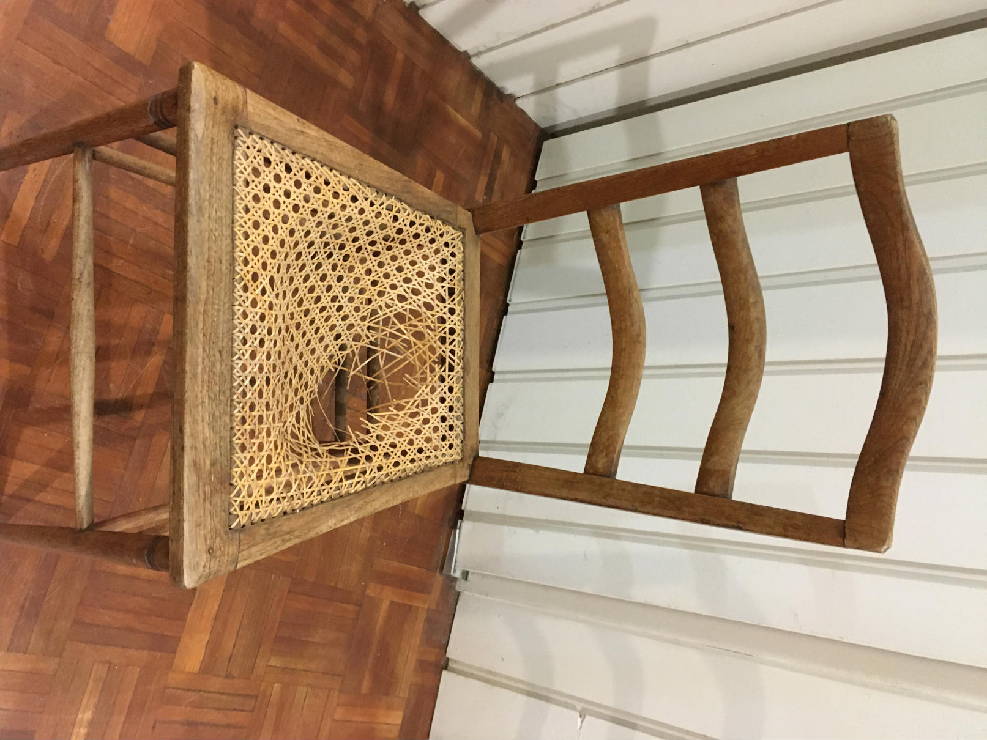 | This is a chair that a lady from Millthorpe brought to me this week to recane. It looked simple enough until I realised that instead of the usual 6 stage process of 2 verticals, 2 horizontals and 2 diagonals (Doug and Peter S will understand this, even if no one else does!) it has 1 vertical, 1 horizontal and 4 diagonals. I couldn't find any reference to this pattern in my books – a reminder that EVERY chair I tackle is a learning experience!
John has sent through a couple of interesting pieces - one on moulding planes and another on the stool making workshop he recently attended with his family – I'll include these in the next newsletter, but in the meantime here is a poem John has also provided.

Keep well,
Elizabeth

26.3.2020

Poem of the week (author unknown,contribution from Heather Kirk)
What a year this week has been.
What happens now? Are we lost in the dark?
Is our world in lockdown? Have we lost our spark?
Is school really cancelled? Can we have a play date?
And if there is no school, can we please stay up late?
How do I answer these things my kids ask?
That people aren’t sick if they are wearing a mask.
But dad, you have taught me for ages to shake hands with a grip
And will we ever embark on that overseas trip?
Yes it seems like we are wrapped in a sanitised curtain
And it is really not easy to embrace the uncertain.
You see, this thing is global, we are fighting a war
Yet we are our army that we are looking for.
How do we win dad? Can we beat this thing?
And if I’m a soldier what must I bring?
In all wars my boy, there will be real tears and fears
But I am learning too about some helpful ideas.
We are not alone, although we are in isolation.
There are soldiers like you in every nation.
Be kind to others and never be mean
And healthy soldiers always stay clean.
Don’t shake hands in a greeting, please wash your hands.
You have many strong allies in far away lands.
Keep your social distance, give others space
You can still greet with your eyes and smile with grace.
For physical bonding, give your elbows a bump
We will flatten this curve and decrease this hump.
And while it is imperative to look after yourselves
For god sake leave something on the grocery shelves.
This war is real and people lie dying
And their cause isn’t helped by our panic buying.
Great soldiers stay calm, they stay clear of insanity
And this is the time to really practice humanity.
Yes my girl, there will be an end to this bug
And the times will come back to kiss and to hug.
Look up from your laptop, keep your feet on the grass
And like all things in life this too shall pass.
And through all of this chaos keep your sense of humour
Because nothing spreads quicker than gossip and rumour.
This might be the craziest time our world has ever seen
But we will look back and say what a year this week has been.
So read that good book, get out and play
For the sun will still rise like it has everyday.
The greatest weapons we have are to love and to care
Hold your army close in thought and in prayer.
I don’t know too much but I know this is true
That the smog skies of Wuhan are turning quite blue.
There will be an end to this calamitous weather
And like all great teams before us we’ll be stronger together.

