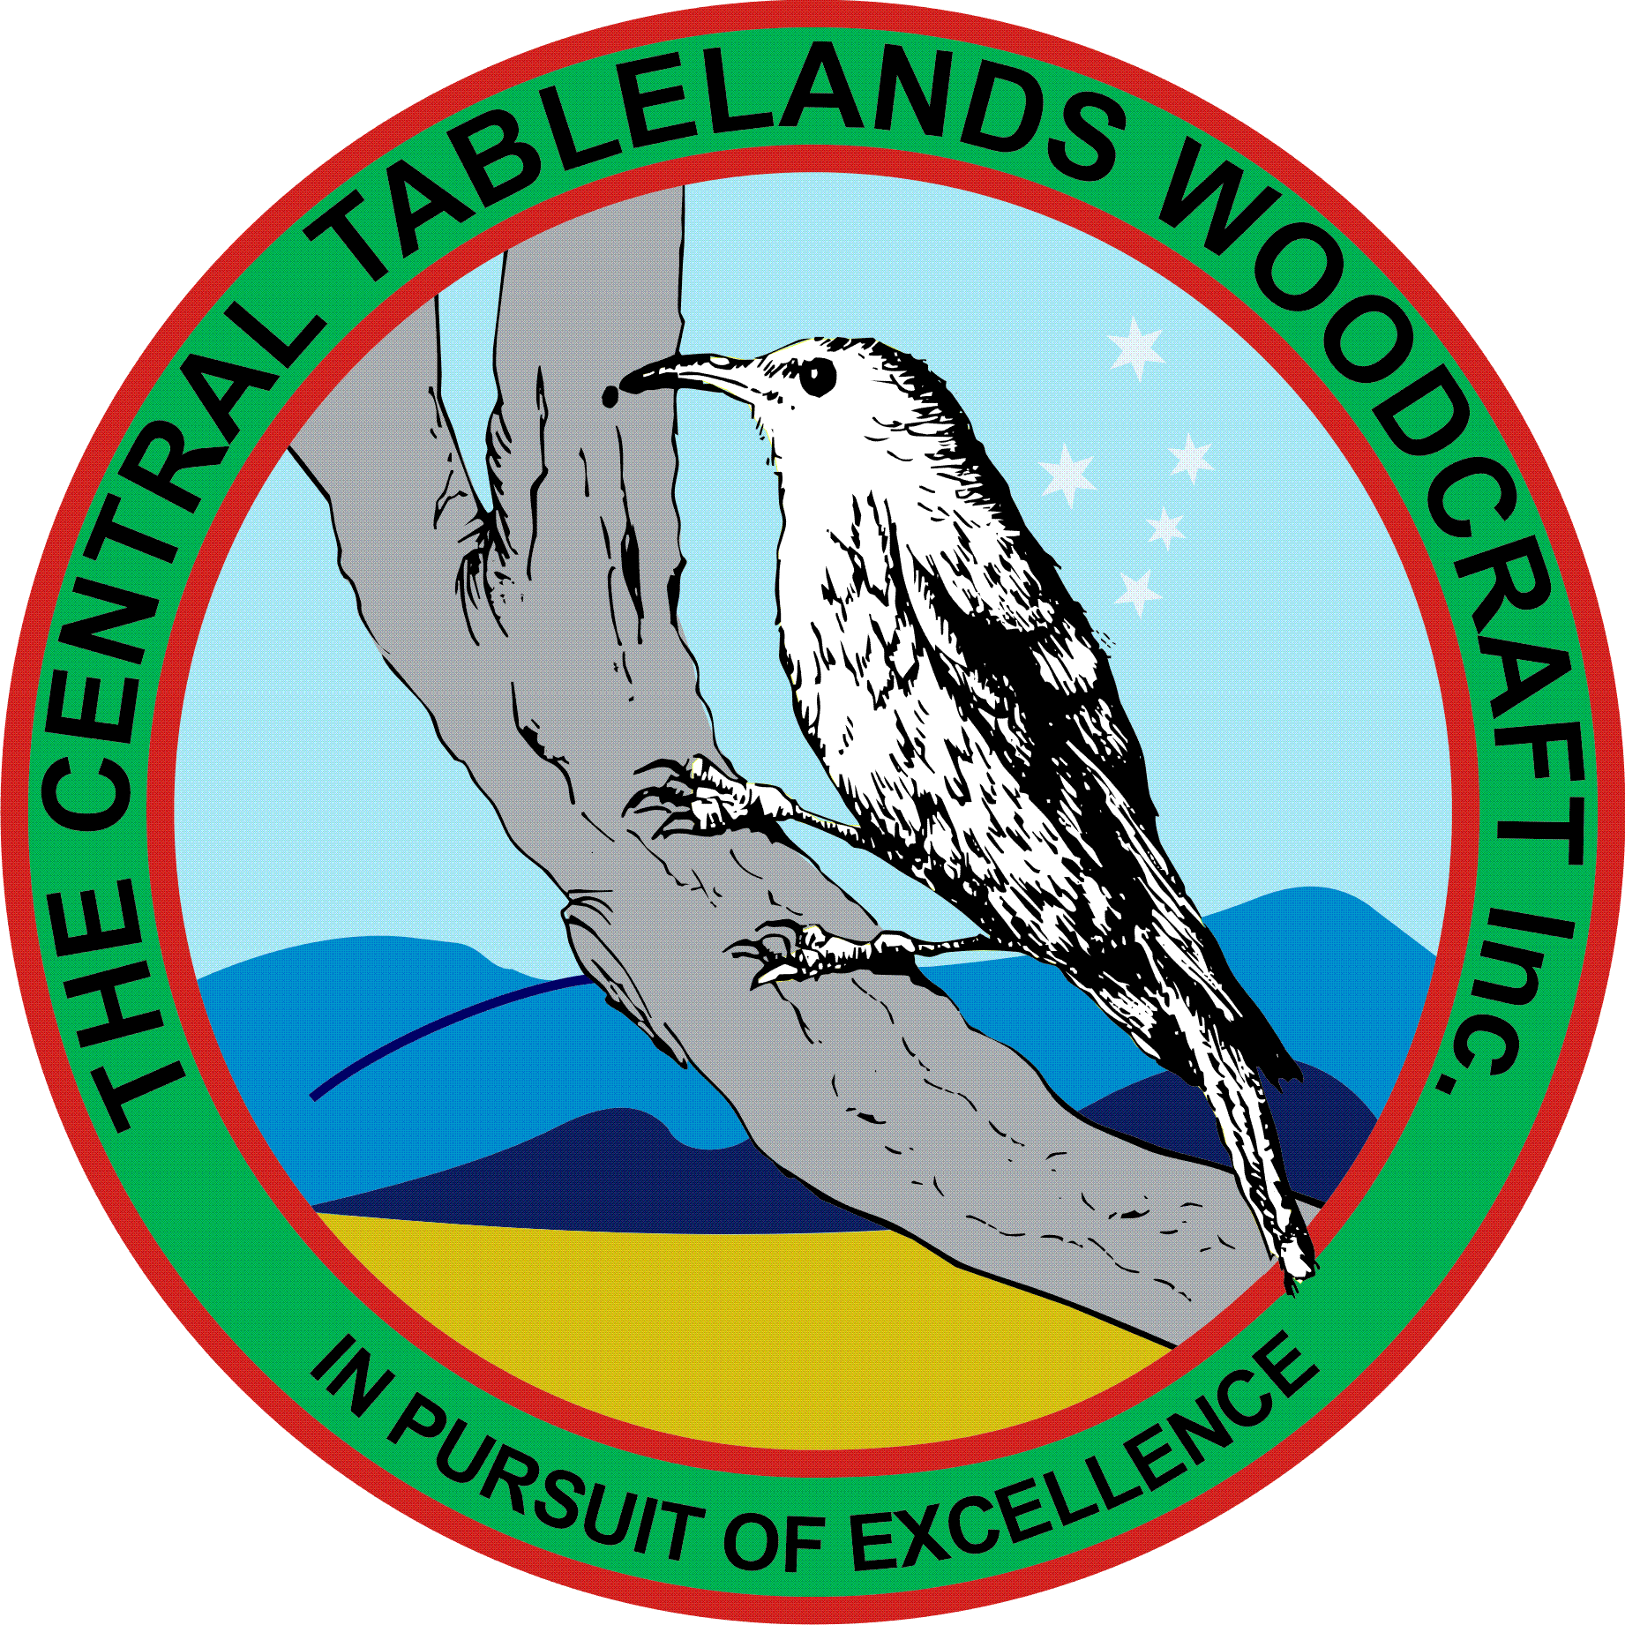
Central Tablelands Woodcraft Newsletter
September 2019
As all members would be aware, a tender from Central Tablelands Constructions has been accepted for the refurbishment of the toilet block and work will commence shortly with Council managing the project.
The proposed voluntary worker insurance has been put in place and the premium paid.
The two pre-Father’s Day events have both been completed and were very successful.
- At Bathurst city Centre on Friday 23/8 and Saturday 24/8 with equipment delivery and setup on the Thursday from 1600hrs.
- At Bunnings on Thursday 29/8 from 1800hrs – a number of members attended.
There are also some events that members were involved in:
- Trivia Night at Magellan Club on Friday 13 September in aid of PCYC.
- Perthville Village Fair on 14 September.
With W.O.S coming up in November, it is necessary for members to be making items both for sale and to enter into the competition. Jim and Jacko will be harassing members for competition items over the coming weeks.
Sponsors for W.O.S are coming in with more to follow shortly. Tasks for committee have been allotted and work is proceeding.
A new order for Club shirts has been placed near the sign on sheet and members are encouraged to place orders, however with the issue of members ordering last time and not picking up, we will be collecting full payment prior to orders being placed .
There has been some discussion regarding the kitchen as, with so many members now attending the facilities, there is not enough room. It has been decided that Paddy manage this project..
CLUB PROJECTS
- Knitting Nancies Jim Hallahan (ongoing)
- Limber-jacks Colin and Paul (ongoing)
- Gun Cupboard (shelves made, cleats fitted awaiting finish) Doug, Ian, Graham
- Lid for Baptismal Font Dick Smith
- Chair Restoration (arm carved) Graham (completed)
- Honour Board for Perthville School Jacko (completed)
- Scout Badge Board (framer made; Perspex fitted) Doug (completed)
- Name Badge Box for Probus Jacko (underway)
- Indoor Bowling Slide John Mc
- Kitchen Paddy
- Lowering of table Jacko & Peter
- Screen Print Frames Jacko
- Saw Handle Jacko & Bob (completed)

Local Federal member Andrew Gee will be visiting our Club rooms on Wednesday 26 September for morning tea - members are reminded that this is in no way a political visit and we need to be undertaking activities to demonstrate what it is that we do.
The Club Christmas Party will again be planned by Bob Cassidy and will be held on 13 December.
With the prizes for our raffle now confirmed, members will receive tickets to be sold prior to W.O.S so please plan to receive these in the coming week.
A reminder that ANY item that is presented for sale MUST have a ticket affixed and correctly filled out - if you are unaware of how to do this contact one of your committee members..

